

***GRACIOUS GARMENTS***

**For more support visit our website**

**www.GraciousGarments.com**

# *PIQUÉ POLO SHIRT*

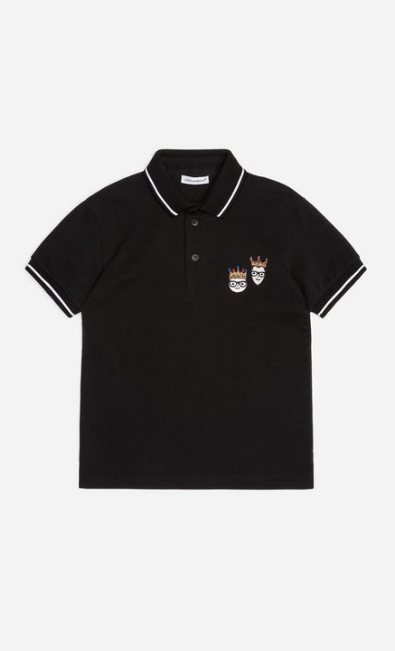

Our product are made of the most comfortable, highest quality fabric out there today. The tri-blend cotton-poly mix comes from none other than American Apparel in Los Angeles, while the printing is done right here in Dayton by our partner Four Ambition. With these product, you not only feel the difference in comfort, but also feel the pride in bearing the logo of one of the world’s most famous names.

Add to that the pithy messaging on each shirt. We have created somewhat cryptic messaging on each shirt, accompanied by an enticing graphic that pulls folks in. But no worries, each shirt comes with a hangtag telling the story behind the messaging. Your shirt to everyone you meet. We want YOU to become a brand ambassador, especially since a portion of our royalties goes toward the good work of The Adidas US in helping to preserve and promote the legacy of the Adidas US and aviation heritage worldwide. With that much meaning attached to them, you’ll likely want to collect them all!